**Assignment**

https://www.youtube.com/embed/KLlXCFG5TnA

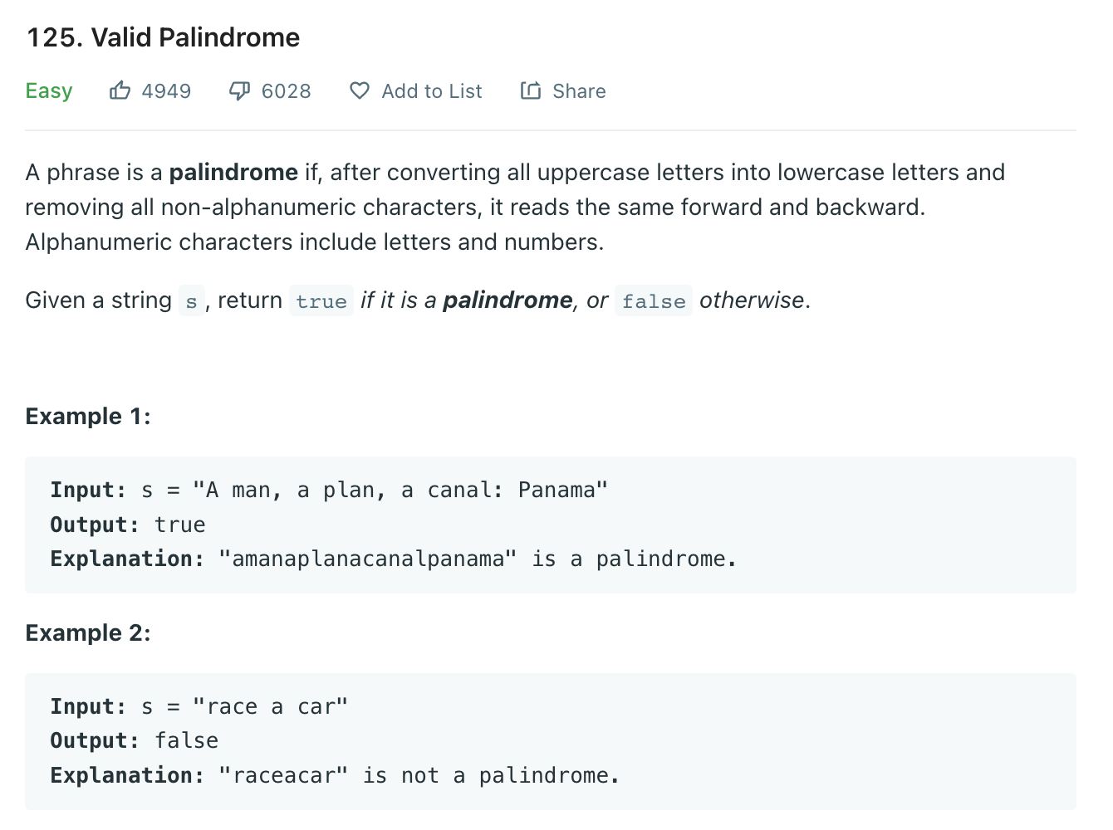

https://www.youtube.com/embed/jJXJ16kPFWg

<https://www.youtube.com/embed/3OamzN90kPg>

<https://www.youtube.com/embed/UuiTKBwPgAo>

https://www.youtube.com/embed/WTzjTskDFMg